**Sample Phishing Email of MasterCard**

**From: IT Security Team <it-security@mastercard.com>  
To: mathew@email.com  
Subject: 🔒 Action Required: Mandatory Password Reset Notification**

**Dear Mathew,**

**We have detected unusual activity associated with your corporate email account. As a precautionary measure to safeguard your account and confidential data, we require you to reset your password immediately.**

**Please follow the secure link below to initiate the password reset process:**

**👉 Reset Password Securely**

**⏰ This link will expire in 60 minutes. Failure to complete the reset within this time may result in temporary suspension of your account access.**

**If you did not request this or believe it to be an error, please contact the IT Service Desk immediately.**

**Thank you for your cooperation in maintaining our cybersecurity protocols.**

**Best regards,  
Mastercard IT Security Team  
security.support@mastercard.com**[**www.mastercard.com**](https://www.mastercard.com)

**Sample Phishing Email of Microsoft Account Verification**

**Subject: 🚨 Immediate Action Required: Unusual Sign-in Attempt  
From: Microsoft Security Team <no-reply@microsoftsupport.com>**

**Dear Ramesh,**

**We detected a sign-in attempt from an unknown device using your Microsoft account.**

**Time: May 29, 2025  
Location: Moscow, Russia  
Device: Windows PC**

**If this wasn't you, please secure your account immediately:  
🔐 Review Activity & Secure Account**

**Your safety is our priority.  
– Microsoft Account Team**

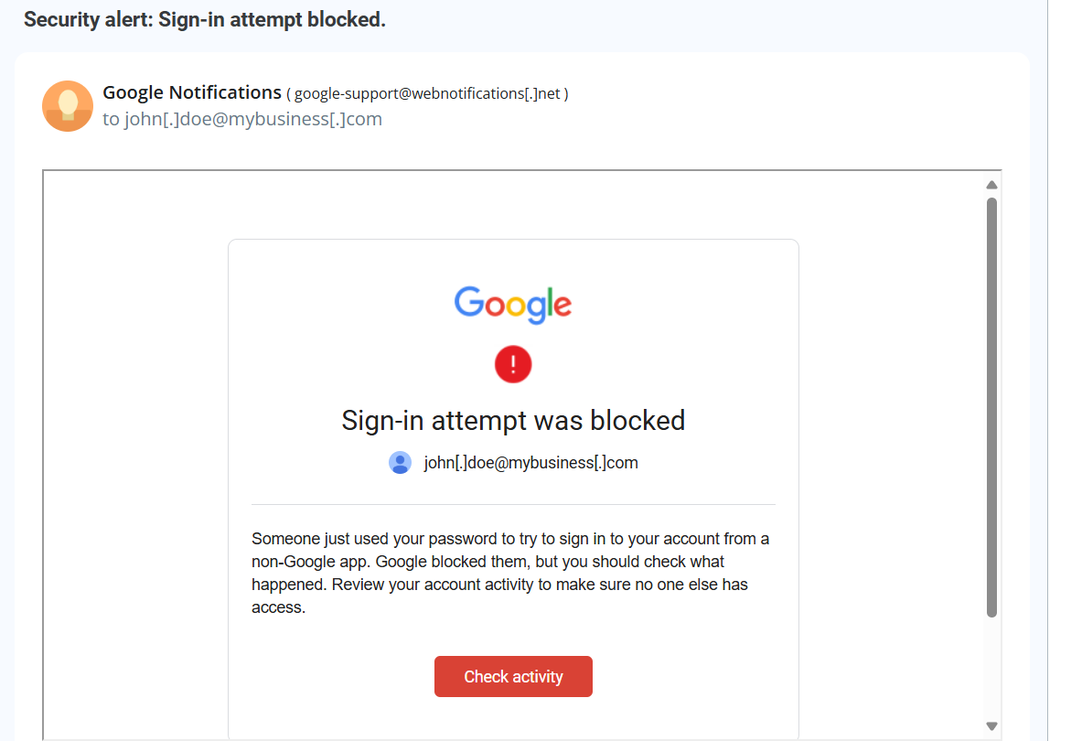

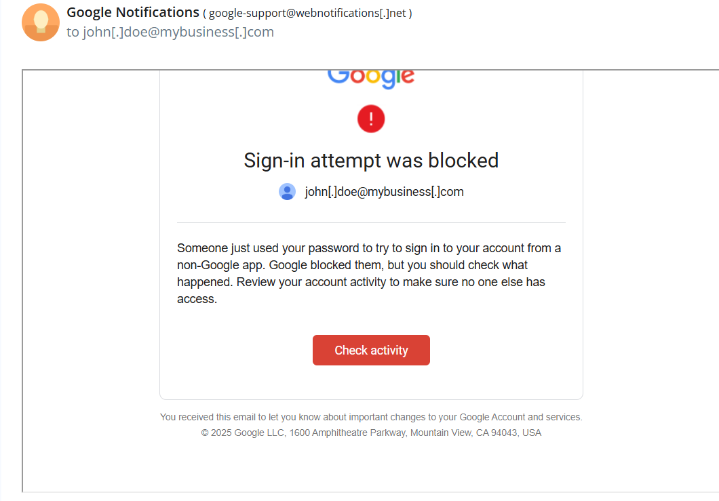

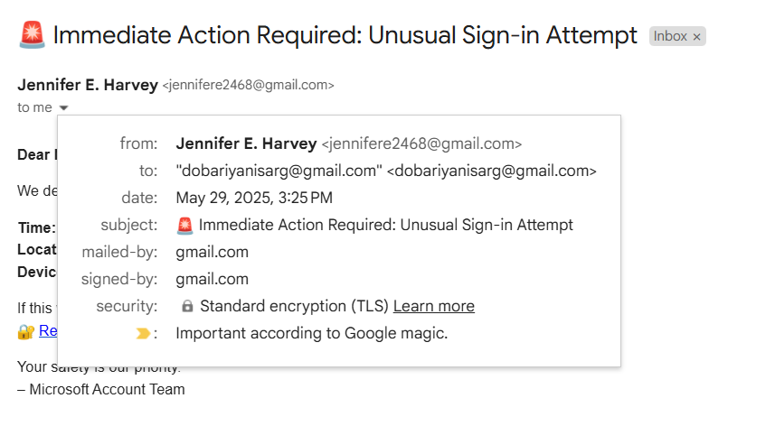

Urgent Language

Fake email address

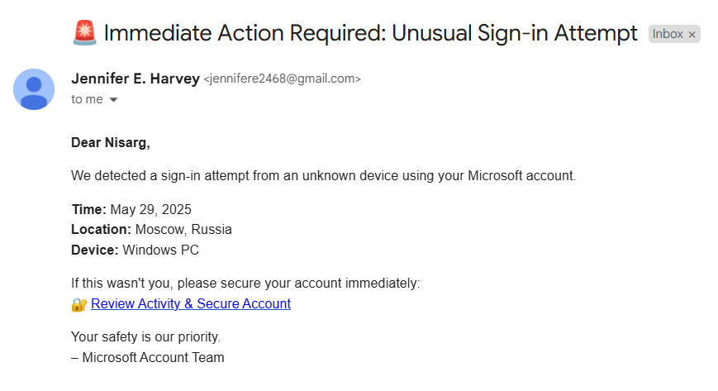

Suspicious link

Fake Login Details